Introduction to Sectors Challenge Worksheet
All questions can be attempted after set 1 of independent work questions.

Question 1
Express the following sectors as simplified fractions of their original circles. Attempt first without your calculator.
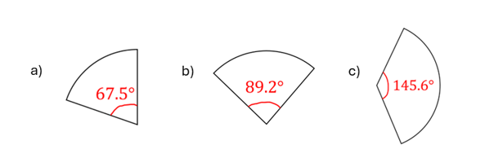

Question 2
A circle is divided into congruent sectors, each with a central angle of 18°. How many such sectors fit exactly into the circle?

Question 3
Show that the below two sectors, with the same radius, cannot fit exactly together. How many more degrees are needed to make them fit?
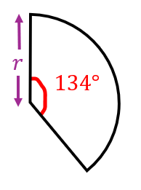
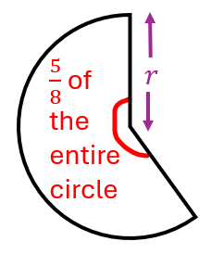

Question 4
Express the sector with a central angle that is a multiple of 5° as a simplified fraction of the full circle.
